Drone Based Mapping and Ground Based Robotic Precision Spray System for Field Crops

AgAID

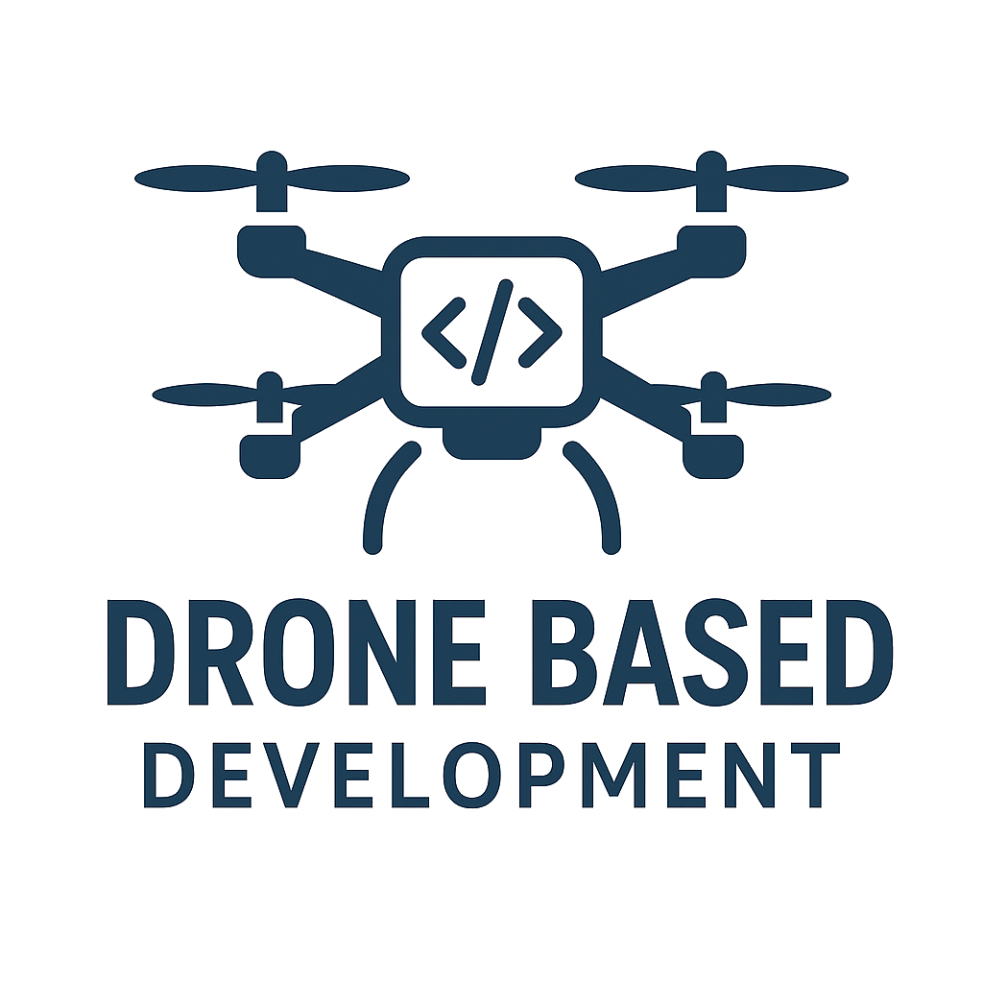


Gil Rezin
Logan Sutton

Introduction
Andrew Nelson, a fifth-generation farmer and former software developer, uses and implements advanced tech solutions throughout his Palouse farm. These solutions, from Raspberry Pis in grain silos to heavy-duty spraying drones, help Andrew lower labor costs and manage his farm efficiently. One of Andrew’s goals is to automate the spraying of a 20-acre wheat field as a proof of concept for future automated pesticide application. Using drone imagery and machine learning, Andrew aims to generate an AI-based prescription and path for a spraying robot, enabling the robot to perform optimal variable rate spraying on his field.

Background and Related Work
Precision agriculture has emerged as a valuable strategy for addressing problems in modern farming. This solution allows for responses to in-field variability, minimizing expenditure of critical resources [1]. Some typical precision agriculture solutions include drone sprayers, variable rate technology, and tractor guidance. Our solution seeks to maximize pesticide application efficiency, both with variable rate controlling and optimal path finding. This will be implemented by building upon the concept of drones in agriculture, along with robotic sprayers.
The motivation behind this project also involves entry into the Farm Robotics Challenge. This challenge allows college students to tackle real-world agricultural challenges with robotic solutions [2]. There is a $50,000 SAFE investment as a prize for the top-performing team. Andrew Nelson is the sponsor for the WSU-based team.
The required tech stack involves knowledge of Python, Pix4d, and WebODM. Pix4d and WebODM are professional drone mapping software, which we will use to stitch together aerial images into orthomosaic maps. WebOdm is the open-source counterpart to Pix4d, and aligns better with our goal of providing open-source software to farmers. Both are accessible for our development needs, but knowledge of WebODM will be critical.

Project Overview
Farmers face increasing challenges in pesticide application due to labor shortages, increasing input costs, and limitations of existing equipment. Drone sprayers, though promising, are hindered by inaccuracy, require frequent refills, and are not able to fly effectively in windy conditions. These inefficiencies, coupled with increased exposure to chemicals, make drone spraying non-optimal. The need for a practical and accessible solution is imperative.
The goal of this project is to utilize machine learning to automate and optimize pesticide application. We will use drone imagery and imagery analysis tools, open source software, and a custom robotic sprayer to apply pesticides in a test field effectively and efficiently. Specific requirements include:
- Use drone imagery and AI to build prescriptions for spraying
- Transfer prescriptions to the robot sprayer for variable-rate application
- Vary the spray rate across the boom using individual nozzle controls
- Validate effectiveness and determine optimal boom width
The solution to this problem should utilize open-source, locally run software for ease-of-use and be designed with larger, farm-ready robots in remote locations. Additionally, the final product needs to be an accessible system utilizing off-the-shelf components.
Our project’s analysis will be conducted over a 20-acre wheat field located in Farmington, WA. The objective is a data analysis and optimization problem: find the minimal amount of pesticide that will cover the field’s crops while ensuring complete field coverage (current application levels use 8 refills of pesticide for full coverage). Prior data collection has been conducted via drone, obtaining detailed classifications for each level of pesticide application necessary per measured cell.
Our desired output is as follows: Given an input of data about the field, return a list of instructions for the sprayer robot to follow, including timestamp-specific navigation and individualized nozzle control for fully autonomous, optimized pesticide application.
There are a number of specialized libraries and tools utilized for this project. Pix4d is a photogrammetry software suite designed for drone mapping and visualization, particularly for agricultural purposes. This is our main data container around which the model will be built. WebODM acts as a supplementary program for drone mapping and image processing. The farm robot is supplied by farm-ng: it will act as the autonomous vehicle from which commands generated by the model are executed, and a base from which our hardware team will be working on over the course of the year.
Aside from our previously collected drone data, there is no prior codebase to build from. Due to competition restrictions, no existing codebase for a given project is permitted. Everything in our codebase will be written by us.

Client and Stakeholder Identification and Preferences
Jordan Jobe - project coordinator for AgAID & Project Sponsor, who manages the AgAID program and our project communications with clients. Expects project completion in a swift and timely manner before the Farm Robotics Challenge.
Andrew Nelson - Owner of Nelson Farms & Mentor, who owns our testing grounds and gathers drone data for the project. By reducing labor and input costs on his farm, he represents future product users.
Lav Khot - WSU Associate Professor in the Department of Biological Systems Engineering, project overseer. Expects the project to be utilized in future academic research.
Dattatray Ganesh - WSU Graduate Student, assistant project team coordinator. Expects the project to be utilized in future academic research.

Glossary
AgAID - National AI Research university program for use of artificial intelligence within agricultural fields.
Pix4d: Professional photogrammetry software suite for drone mapping and visualization.
Raspberry Pi - low-cost computer used in simple computing solutions, such as sensor monitoring.
WebOdm: A free, user-friendly, extendable application and API for drone image processing.

References

- A. Ashworth and P. Owens, “Benefits and Evolution of Precision Agriculture,” Agricultural Research Service, U.S. Department of Agriculture, Under the Microscope, January 10, 2025. [Online]. Available: https://www.ars.usda.gov/oc/utm/benefits-and-evolution-of-precision-agriculture/. [Accessed: Sep. 18, 2025]
- Farm Robotics Challenge, “The Farm Robotics Challenge,” UC Agriculture & Natural Resources Innovate, AI Institute for Next Generation Food Systems, [Online]. Available: https://www.farmroboticschallenge.ai/. [Accessed: Sep. 18, 2025]

